

CENTER FOR RESEARCH IN ADVANCED MATERIALS, S. C.
POSTGRADUATE

Mean and Effective PermitTivity in Textured Ferroelectrics

Thesis as required to obtain a Degree of Master in Material Science presented by:

Lic. Armando Rodriguez

Thesis Director:
Dr. Luis E. Fuentes Cobas

Chihuahua, Chih. Diciembre de 2006

Acknowledgements:

Acknowledgements are usually a formal thing, something that you are just supposed to do. In such sections, the only one written in the first person of the singular, thanks are given to associates, wives, parents, family members, coworkers, agents, ah! Bosses (no one can skip this), and so many others that are acknowledged for being of utmost importance to the accomplishment of reference, but that, in fact, may not have been nearly as relevant as suggested.

This is certainly not the case, if not, ask yourself why is this sixty plus guy from Florida defending a thesis in Chihuahua’s CIMAV, aren’t there enough universities and research centers nearer by? Of course there are, but they have no Dr. Fuentes in their staffs. So, when I say the typical phrase: “I couldn’t have done it without the help of Dr. Fuentes”, it is not just political correctness, is as true as the hypothesis in the chapter below can be.

From Dr. Fuentes, not only had I learned everything I know about the subject and that with his support, I had the undreamed privilege of working at the Stanford Synchrotron, but that, making a long story short, he brought me back to Physics.

It may have been for the good o’l times when we studied together back in the 60’s or maybe for being a team in the 70’s when we dared to teach Berkeley physics at a very much soviet oriented Havana University, yet, I think that above all, what moved him on this effort, was his justice seeking nature, the desire to repair an old injustice, the one than banned me from defending my PhD thesis in 1978 for not being “politically reliable”.

I want to thank my old friend for being a friend in total disregard of his being one of the biggest names in the field and for finding value in such a modest contribution as mine. Also and not for political correctness, but from the bottom of my heart, I want to thank everyone at CIMAV…for giving me a second chance at being what I always wanted to be, a Physicist.

Yet, though it may sound as stereotyped as the list I made fun of in the first paragraph, I want to dedicate this work to my wife Mabel for making hers this quest of mine and for taking with love the prolonged lack of attention coming from this effort.

Table of Contents
Acknowledgements: 2
Table of Contents 3
Mean and Effective Permittivity in Textured Ferroelectrics 4
I. Introduction and Background 4
II. Hypothesis 6
III Development 8
III.a Measured Quantities and Volume Averages 8
III.b E Constant Assumption Renders an Upper Limit for Effective K 9
III.c D Constant Assumption Renders a Lower Limit for effective K 11
III.d Limits Must Prove to Hold in a Simple Case 12
III.e Textures may Determine the Best Independent Variable 13
III.f Error calculation for the Perpendicular Case 15
III.g Error calculation for the Parallel Case 19
III.h Effective Dielectric Constant Calculation, Perpendicular Case 24
III.i Effective Dielectric Constant Calculation, Parallel Case 29
III.j Comparison to experimental results 30
IV Conclusions 33

Mean and Effective Permittivity in Textured Ferroelectrics

I. Introduction and Background

The objectives of present investigation are:
- To contribute a detailed discussion of the physics behind the so-called “mean approximation” to the problem of calculating the effective permittivity in textured ferroelectrics.
- To estimate the uncertainty introduced by the mentioned approximation.
- To propose an optimum procedure for predicting the effective permittivity in the particular case of Aurivillius ferroelectrics.
- To check the correctness of the proposed criteria by comparison with published experimental results.
The theoretical background required by this document is the following:
- Crystal Physics,,
- Classical Electrodynamics,
- Mathematical Texture Analysis,,,.
Application of Mathematical Texture Analysis for the characterization of electromagnetic properties of polycrystalline materials has been discussed by Fuentes and collaborators,.

It is well known that the macroscopic effective and mean values are equal only if the independent variable is constant throughout the volume of the sample (Ref. 6). Fuentes, Rodríguez, Aquino and Muñoz have obtained an effective value of the permittivity for a PbBi₄Ti₄O₁₅ ceramic sample by assuming constant electric field E. Though in their paper, it is mentioned that this is only one of two extreme situations named after their original proponents Reuss and Voigt, the first is taken without further discussion of which could render a better approximation.
The following approach has been proposed by Hill.
$\left\langle K\right\rangle =(1/2)[\tilde{K}+(1/{\tilde{I}})]$ (I.1)
K is the considered property and I = K⁻¹. In this thesis, K is the dielectric constant and I is the impermittivity. In CGS units system, K gives directly the permittivity. In MKS International System, a medium permittivity is ε = Kε₀, where ε₀ is vacuum permittivity. Formula (I.1) is widely used in practice, yet limits to the error are rarely estimated. This is probably because the values so obtained are mainly used as seeds in auto consistent calculations. In textured ceramics though, averages of some components of the dielectric tensor can come quite close to its effective value and if an error could be estimated, average values could be used directly, not only as a seed.

In the presence of textures, boundary value analysis for fields E and D can determine the best choice for the independent value in dielectric property calculations, but this kind of discussion did not show in our search through the literature.

In this work it will be proved, that with the symmetry of common experimental conditions, the constant E assumption renders an upper limit to the effective dielectric constant in the direction of the measuring field, while D constant a lower limit. Also that textures and the direction of measuring fields can determine the best choice of independent variable for property calculations as well as an error estimate.

To evaluate the correctness of the theoretical criteria established in the investigation, comparison with published data is performed. Experimental results obtained by Hong et al are considered. The mentioned article reports structural characterization and electrical properties measurements for a typical Aurivillius phase: bismuth titanate. As part of our research, we discuss on quantitative basis the texture-dielectric phenomena relationship for this material. The mean approximation treatment, as developed by Fuentes et. al. (Ref. 12) is taken as reference. Fuentes et. al., in a systematic approach involving the expansion of the texture orientation distribution function (ODF) in spherical harmonics, obtained the dielectric longitudinal surface for a textured sample assuming constant E. This approach has the “one-size-fit-all” problem. The average K fits the effective permittivity for any-axis normal to the preferred (001) direction, but performs poorly for the preferred axis. It will be proved that it was the result of this assumption what caused that the longitudinal surface obtained showed less anisotropy than experimentally observed.

II. Hypothesis
The present work is based on the assumption that following is true without prove:
Maxwell equations for electrostatic fields:
$∇⋅D=−ρ$ (II.1)
where ρ is the free charge volumetric density.
$∇\text{xE}=0$ (II.2)
$\begin{aligned}\tilde{D}=ε_{0}\tilde{K}\tilde{E}+{ε_{0}}/V\int_{V}{ΔKΔ\text{Edv}} \\ \text{where} \\ \tilde{X}=\int_{V}{{\text{Xdv}}/V} \\ \text{and} \\ ΔX=X−\tilde{X}\end{aligned}$ (II.3)
The volume element in the Euler space:
${\text{dv}}/V=\frac{p(θ)\text{sin}(θ)dθ}{2}$ (II.4)
Tensor transform between two reference systems
$I=A^{−1}\text{IpA}$ (II.5)
Definite integrals:
$\int_{0}^{2π}{{\text{sin}}^{2}ϕdϕ}=\int_{0}^{2π}{{\text{cos}}^{2}ϕdϕ}=π$ (II.6)
Euler angles transformation matrix from reference.

III Development

III.a Measured Quantities and Volume Averages

The macroscopic effective dielectric constant is defined as:
$\tilde{D}=ε_{0}<K>\tilde{E}$ (III.1)
Where $\tilde{D}$ and $\tilde{E}$ are volume averages of the fields. For starters, it is only the charge Q and the voltage U, what can be macroscopically measured. Gauss theorem allows Q to be linked to the surface integral of the vector D, which for the plane symmetries of typical experimental setups, matches the average of D on a surface. Stokes theorem, on the other hand, connects voltage U to the line integral of the vector E, which may also be associated with the average of E on a straight trajectory under similar arguments, but still, Q and U are scalar quantities and the averages are vectors, so in any case we would be referring to the module or to some relevant component of the average vectors. How are these volume averages related to the measured quantities?
In a plane symmetry measurement setup the average of E is along the z-axis and then, this would be true:
$\tilde{E}=1/V\int_{V}{\text{Edv}=1/V\iint_{\text{AL}}{\text{Edlda}=1/V\int_{L}{υ(a)\text{da}}}}\text{==}{\text{UA}}/V=U/L$ (III.2)
Since metal plates in plane capacitors at low frequencies are quite equipotential, U(a) is constant. For D along the z-axis, something similar can be proposed:
$\tilde{D}=1/V\int_{V}{\text{Ddv}=1/V\iint_{\text{LA}}{\text{Ddadl}=1/V\int_{L}{Q(l)\text{dl}}}}=(L/V)Q=Q/A$ (III.3)
In absence of free charge, Q(l) is constant at any l, and so the volume average is the same as the area average, but if there are leakage currents, this might no longer be true. In case of crystallite anisotropy, microscopically D may not be parallel to E, but symmetry will force their sample averages to be.

III.b E Constant Assumption Renders an Upper Limit for Effective K

Manipulating III.1 or just following Ref. 12,
$\tilde{D}=ε_{0}\tilde{K}\tilde{E}+{ε_{0}}/V\int_{V}{ΔKΔ\text{Edv}}$ (III.4)
Where ΔK and ΔE are differences from the average values. In general, E and D are vector magnitudes and K is second range tensor. A plane experimental setup with the plates in the xy plane, sandwiching a homogeneous sample isotropic in the xy plane, will render both, the average D and the average E, in a direction normal to the conductor plates. Same symmetry considerations prove that the contribution of the volume integral in (III.4), which is a vector, will only have component in z. $\tilde{K}$ is still a tensor, of which can be said that isotropy in xy makes ${\tilde{K}}_{\text{11}}={\tilde{K}}_{\text{22}}$and that only ${\tilde{K}}_{\text{33}}$ is relevant to the measurement.
$\tilde{D}{\vec{u}}_{3}={\vec{u}}_{3}ε_{0}{\tilde{K}}_{\text{33}}\tilde{E}+{\vec{u}}_{3}({ε_{0}}/V)\int_{V}{\sum_{i}{{ΔK}_{3i}{ΔE}_{i}}\text{dv}}$ (III.5)
Also symmetry proves that there can be no contribution from the components E1 and E3 (Ex and Ey respectively) to its value. Hence:
$\tilde{D}=ε_{0}{\tilde{K}}_{\text{33}}\tilde{E}+({ε_{0}}/V)\int_{V}{{ΔK}_{\text{33}}{ΔE}_{3}\text{dv}}$ (III.6)
And so, only the ΔK₃₃ of the tensor K and the ΔE₃ of the vector E are relevant to the value of the integral in (III.6), which hereon will be called δ.
$δ=({ε_{0}}/V)\int_{V}{{ΔK}_{\text{33}}{ΔE}_{3}\text{dv}}$ (III.7)
Since there’s no free charge, the divergence of D must be zero and so, the Dz flux entering any cylindrically shaped macroscopic dv must be equal to the one leaving it, except for the effect of fluctuation bendings in the D fields, Dz must be fairly constant in z. Still, Dz could be a function of xy, but since we assumed a homogeneous sample, the averages in the total volume must be the same as the one in a column of section dxdy at any (x,y). Then the Dz, which is equal to product K₃₃E₃, must be a constant and if K₃₃ increases E₃ must decrease. One could be tempted, but should refrain to say that if ΔK₃₃ is positive then ΔE₃ must be negative, because that would imply that whenever K₃₃ equals it average, the E equals its average too, but this is may not be true.

Yet, let’s prove it makes no difference to the integral. Assume E_{diff} is the difference between$E({\tilde{K}}_{\text{33}})$, the point were K₃₃ equals the average and the average E.
$\begin{aligned}({ε_{0}}/V)\int_{V}{{ΔK}_{\text{33}}(E_{3}−E({\tilde{K}}_{\text{33}})+E_{\text{diff}})\text{dv}}=({ε_{0}}/V)\int_{V}{(K_{\text{33}}−{\tilde{K}}_{\text{33}})(E_{3}−E({\tilde{K}}_{\text{33}}))\text{dv}+({ε_{0}}/V)\int_{V}{(K_{\text{33}}−{\tilde{K}}_{\text{33}})E_{\text{diff}})\text{dv}}} \\ \text{but} \\ ({ε_{0}}/V)\int_{V}{(K_{\text{33}}−{\tilde{K}}_{\text{33}})E_{\text{diff}})\text{dv}}=(ε_{0}{E_{\text{diff}}}/V)\int_{V}{K_{\text{33}}\text{dv}}+(ε_{0}E_{\text{diff}}{{\tilde{K}}_{\text{33}}}/V)\int_{V}{\text{dv}}\end{aligned}$Since:
$${\tilde{K}}_{\text{33}}=({ε_{0}}/V)\int_{V}{K_{\text{33}}\text{dv}}$$
Then
$$({ε_{0}}/V)\int_{V}{(K_{\text{33}}−{\tilde{K}}_{\text{33}})E_{\text{diff}})\text{dv}}=(ε_{0}{E_{\text{diff}}}/V)\int_{V}{K_{\text{33}}\text{dv}}−(ε_{0}E_{\text{diff}}{{\tilde{K}}_{\text{33}}}/V)\int_{V}{\text{dv}}=E_{\text{diff}}({\tilde{K}}_{\text{33}}−{\tilde{K}}_{\text{33}})=0$$
Which proves that:
$$({ε_{0}}/V)\int_{V}{{ΔK}_{\text{33}}(E_{3}−E(\tilde{K})\text{dv}=}({ε_{0}}/V)\int_{V}{{ΔK}_{\text{33}}(E_{3}−\tilde{E})\text{dv}}=({ε_{0}}/V)\int_{V}{{ΔK}_{\text{33}}{ΔE}_{3}\text{dv}}$$
Now it can be assured that ΔK₃₃ will always have a different sign than ΔE₃ or that the product ΔK₃₃ΔE₃ is negative, so:
$δ=({ε_{0}}/V)\int_{V}{{ΔK}_{\text{33}}{ΔE}_{3}\text{dv}}<0$ (III.8)
This means that when E is assumed constant:
${\tilde{D}}_{3}≤ε_{0}{\tilde{K}}_{\text{33}}{\tilde{E}}_{3}$ (III.9)
Or since, by definition,$\tilde{D}=ε_{0}\left\langle K\right\rangle \tilde{E}$ then:
$\left\langle K_{\text{33}}\right\rangle ≤{\tilde{K}}_{\text{33}}$ (III.10)

III.c D Constant Assumption Renders a Lower Limit for effective K

Equation (III.6) takes the following form when the independent and dependent variables are swapped.
${\tilde{E}}_{\text{33}}=1/{ε_{0}}{\tilde{I}}_{\text{33}}{\tilde{D}}_{3}+(1/{ε_{0}}){\int_{V}{{ΔI}_{\text{33}}{ΔD}_{3}\text{dv}}}/V$ (III.11)
Same arguments hold for the case of the impermittivity I when D is assumed constant. For this case instead of D₃ being constant in z for having zero divergence, it is E₃ that will be constant in xy for being$∇\text{xE}=0$. This renders an equation similar to (III.9).
${\tilde{E}}_{3}≤{\tilde{I}}_{\text{33}}{{\tilde{D}}_{3}}/{ε_{0}}$ (III.12)
Then:
$\left\langle I_{\text{33}}\right\rangle =1/{\left\langle K_{\text{33}}\right\rangle }≤{\tilde{I}}_{\text{33}}$ (III.13)
Finally, for the 33 component:

$(1/{\tilde{I}})≤\left\langle K\right\rangle ≤\tilde{K}$ (III.14)

III.d Limits Must Prove to Hold in a Simple Case

Richard Feynman, Nobel laureate and personal idol, always requested that anything claimed to be generally true after being mathematically “proved”, be shown to hold in a simple case. In compliance to this request, consider a ceramic made up of N types of isotropic crystallites, each type having a dielectric constant Ki or a relative impermittivity of (1/Ki) and a fractional volume v_{III.} If (III.13) is true as proposed, then following must hold true for this case:
$\begin{aligned}(1/{\tilde{I}})=1/{\sum_{i=0}^{N}{({v_{i}}/{\text{Ki}})}}≤\sum_{i=0}^{N}{v_{i}\text{Ki}}=\tilde{K} \\ \text{or} \\ (\sum_{i=0}^{N}{({v_{i}}/{\text{Ki}})})(\sum_{i=0}^{N}{v_{i}\text{Ki}})≥1\end{aligned}$ (III.15)
Doing the product:
$$\sum_{i=0}^{N}{{\sum_{j=0}^{N}{v_{i}v_{i}K_{j}}}/{K_{i}}}≥1$$
Adding another and dividing by two:
$$(\sum_{i=0}^{N}{{\sum_{j=0}^{N}{v_{j}v_{i}K_{j}}}/{K_{i}}}+\sum_{i=0}^{N}{{\sum_{j=0}^{N}{v_{j}v_{i}K_{j}}}/{K_{i}}})/2≥1$$
Changing the indexes to the second and regrouping:
$$\sum_{i=0}^{N}{{\sum_{j=0}^{N}{v_{j}v_{i}(K_{j}}}/{K_{i}}}+{K_{i}}/{K_{j}})/2≥1$$
Now if we say x = Ki/Kj, what we have inside the parenthesis is the function (x+1/x), typical calculus exercise. This function has a minimum of 2 for x=1. If for this minimum, the inequality still proves true, then it would be true for any other set of Ki.values. Finally, since the sum of all the fractional values must be 1:
$$\sum_{i=0}^{N}{\sum_{j=0}^{N}{v_{j}v_{i}(2}})/2=\sum_{j=0}^{N}{v_{j}}\sum_{i=0}^{N}{v_{i}}=1$$
This proves that left hand side of (III.15) is always equal or greater than one.

III.e Textures may Determine the Best Independent Variable

Yet, in absence of a texture, no further conclusions can be drawn besides knowing the range in which the effective value lies within. Going back to the bismuth titanate, its (001) oriented-wafer-pile structure allows further insight (Ref. 12). Let’s assume that the texture is such that the wafers are likely to be aligned normal to the measuring field (the case referred as perpendicular, as opposed to parallel, by Hong et. al. in Ref. 4).

Figure 1 shows and example of sample preparation for perpendicular measurement.
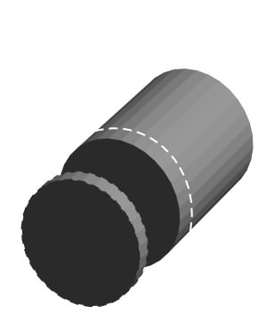
Figure 1 Sample preparation for the perpendicular case

To make the right choice we must answer the following question: What changes more in the whole volume, Ez or Dz? We have proven that both ΔK₃₃ΔE₃ and ΔΙ₃₃ΔD₃ must be always negative for homogeneous samples showing isotropy in the xy plane. This is why every departure from the average value, no matter in which direction, will contribute to the difference between the effective and the average values.

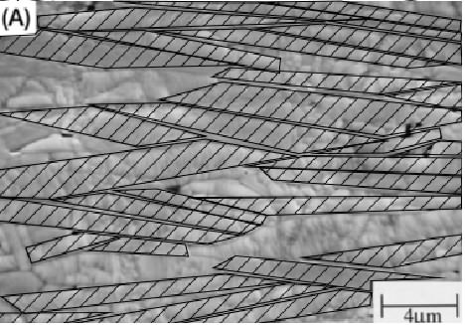
Figure 2 SEM Microphotograph of a transverse section of an Nd doped Bismuth Titanate sample, showing wafer shapes (Ref. 14).

As will be proven bellow, K₃₃ will be a function of the wafer inclination, then, from Figure.1, it becomes obvious that K₃₃ changes more with z than with xy. If we traveled in the z direction, changes in the dielectric constant bring about polarization charges that make E discontinuous. The D lines will bend with wafer inclinations, but will not disappear at their surfaces as their E counterparts. If we moved in the xy plane, there will be fewer changes of any kind for the same distances than in the z direction, but still Ez must change from wafer to wafer, while changes to Dz remain minor. Hence, for this texture and for the perpendicular case, the best choice for independent variable is D.

It would be nice to know, not only that D is a better independent variable choice, but how good it is and see if it actually renders values closer to the experimental ones than those reported in Ref. 2.

III.f Error calculation for the Perpendicular Case

Consider an arbitrary interface surface between crystallites 1 and 2, which is inclined an angle θ from the z-axis as shown in Figure 2.
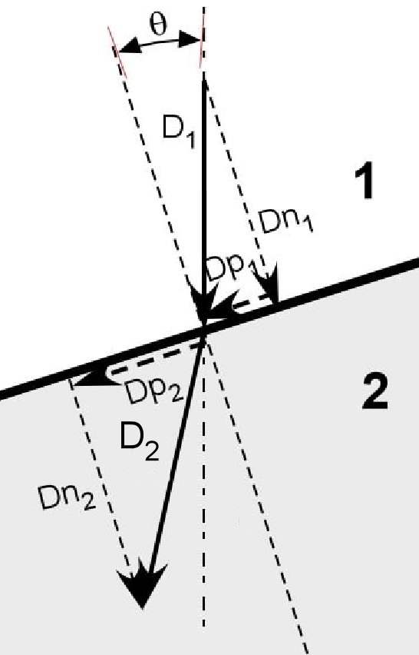
Figure 3 Intercrystallite boundary showing the D vector components

Let Dn1 and Dn2 be the components of D normal to the surface at both side of the interfacing surface. Since there is no free charge at the interface:
${\text{Dn}}_{1}={\text{Dn}}_{2}$ (III.16)
Since the parallel component of E must be continuous at the surface to comply with$∇\text{xE}=0$, then:
$\text{Ep}={\text{Ip}}_{1}{\text{Dp}}_{1}={\text{Ep}}_{2}={\text{Ip}}_{2}{\text{Dp}}_{2}⇒{\text{Dp}}_{2}=({{\text{Ip}}_{1}}/{{\text{Ip}}_{2}}){\text{Dp}}_{1}$ (III.17)
Since only the z component is relevant for this estimate, as discussed earlier for equation III.6, we need equations in those terms. Consider that D₁ happens to be equal to the average, then:
$\begin{aligned}{\text{Dn}}_{1}=\tilde{D}\text{cos}θ \\ \text{and} \\ {\text{Dp}}_{1}=\tilde{D}\text{sin}θ\end{aligned}$ (III.18)
But:
${\text{Dz}}_{2}={\text{Dn}}_{2}\text{cos}θ+{\text{Dp}}_{2}\text{sin}θ={\text{Dn}}_{1}\text{cos}θ+({{\text{Ip}}_{1}}/{{\text{Ip}}_{2}}){\text{Dp}}_{1}\text{sin}θ$ (III.19)
Ip₁ must also correspond to the average case. Combining (III.18) and (III.19) and denoting Ip₁ as$\tilde{I}p$.
${\text{Dz}}_{2}=\tilde{D}{\text{cos}}^{2}θ+(\tilde{I}p/{{\text{Ip}}_{2}})\tilde{D}{\text{sin}}^{2}θ=\tilde{D}+(\tilde{I}p/{{\text{Ip}}_{2}}−1)\tilde{D}{\text{sin}}^{2}θ$ (III.20)
(III.20) can be used to express the relative deviation defined by:
${{ΔD}_{3}}/{\tilde{D}}={{ΔD}_{z}}/{\tilde{D}}=({\text{Dz}}_{2}−\tilde{D})/{\tilde{D}}$ (III.21)
Combining (III.21) and (III.20)
${{ΔD}_{3}}/{\tilde{D}}=(\tilde{I}p/{{\text{Ip}}_{2}}−1){\text{sin}}^{2}θ$ (III.22)
Equation (III.11) can be manipulated into:
$(\left\langle I\right\rangle −\tilde{I})/{\tilde{I}}=\int_{V}{({{ΔI}_{\text{33}}}/{\tilde{I}})(}{{ΔD}_{3}}/{\tilde{D}}){\text{dv}}/V$ (III.23)
Where the right hand side,$(\left\langle I\right\rangle −\tilde{I})/{\tilde{I}}$ is the relative error when considering the effective value as the average.

Since the sample symmetry-axis is parallel to z, taking dv as the fractional volume occupied by crystallites having its lattice axis inclined by an angle between θ and θ +dθ to the sample’s symmetry-axis, then (for a more detailed justification of the expression below, see the one for equation (III.60)):
${\text{dv}}/V=\frac{p(θ)\text{sin}(θ)dθ}{2}$ (III.24)
Where p(θ) would be the sample’s (0,0,1) Direct Pole Figure. Also:
${ΔI}/{\tilde{I}}=(I−\tilde{I})/{\tilde{I}}=(I/{\tilde{I}}−1)$ (III.25)
Combining (III.22) through (III.25)
$(\left\langle I\right\rangle −\tilde{I})/{\tilde{I}}=(1/2)\int_{0}^{π}{(I_{\text{33}}(θ)/{\tilde{I}}−1)}(\tilde{I}p/{{\text{Ip}}_{2}}−1){\text{sin}}^{3}θp(θ)dθ$ (III.26)
The wafers larger surface is a (001) plane. On the other hand, looking at Figure 1, it is obvious that most interfacing surfaces are (001) to another (001). Bismuth Titanate wafers are not isotropic around the (001) direction. According to Fouskova and Cross, the dielectric constant tensor components for the single crystal Bismuth Titanate are:

Ka = 120, Kb = 205, Kc = 140 (III.27)

Or

Ia = 0.00833, Ib = 0.00487, Ic = 0.00714 (III.28)

Though some bending of D will take place at these interfaces, any position around the (001) axis is as likely to happen with a value of θ that make $ΔI$positive, as with one that makes it the same, but negative. These bendings do not contribute to the total error. The ones that do contribute are the ones that happen between different (011) lattice orientations, but these are less frequent. Though hardly an exact science, some were marked in Figure 4.

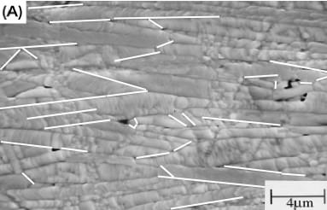
Figure 4 Interfaces with different (001) lattice orientations.

Even when only a part of the volume is going to contribute to the error, in a first approach, we will ignore this. We need now to calculate extreme values for the factors in the integrand. The highest possible value for $I_{\text{33}}(θ)/{\tilde{I}}$ is Ia/Ib and corresponds to the minimum of $\tilde{I}p/{{\text{Ip}}_{2}}$which is Ib/Ia... Substituting these extreme values in (III.26) and taking the absolute value (we already know is negative, we only want to know the size of the error):

$\text{abs}(\left\langle I\right\rangle −\tilde{I})/{\tilde{I}}<\text{abs}(\int_{0}^{π}{({\text{Ia}}/{\text{Ib}}−1)}({\text{Ib}}/{\text{Ia}}−1)\frac{{\text{sin}}^{3}θ}{2}p(θ)dθ)$ (III.29)
The other extreme renders exactly the same expression. Pulling the constants out of the integral:

$\text{abs}(\left\langle I\right\rangle −\tilde{I})/{\tilde{I}}<\text{abs}(({\text{Ia}}/{\text{Ib}}−1)({\text{Ib}}/{\text{Ia}}−1)\int_{0}^{π}{\frac{{\text{sin}}^{3}θ}{2}}p(θ)dθ)$ (III.30)
Fuentes et. al. (Ref. 12) suggested for p(θ), a Gaussian distribution with a standard deviation of 23º (0.4 radians), though this value was calculated for a particular PbBi₄Ti₄O₁₅ sample, we will assume similar texturization for the error estimation purposes. For this distribution the integral adds up to 0.249. Substituting this value together with those in (III.28) in (III.30):

$\text{abs}(\left\langle I\right\rangle −\tilde{I})/{\tilde{I}}<\text{abs}(−0\text{.}\text{073})=7\text{.}3$% (III.31)
(III.30) renders reasonable values for moderate to low anisotropies, like in the case at hand, but with, for example PbBi₄Ti₄O₁₅ (Ref. 7), will only be able to tell us that the error is less than 300%., which doesn’t help much. Some refinement, like the estimation of the partial volume involved in (001) lattice inclination, may lower somewhat this value, but the basic problem is that with high anisotropies <K> and 1/<I> may differ dramatically and the actual effective value may be way off from both limits.

The error also increases with texturization, though not as dramatically. Even assuming an extreme texture so that p(θ) = δ(θ), the error will only increase to 29%, which is still a useful value.

III.g Error calculation for the Parallel Case

Samples for this measurement are prepared by cutting along the axis of symmetry as shown in Figure. 5:
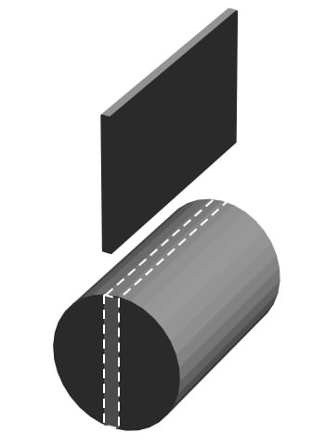
Figure 5 Example of sample preparation for the parallel case.

The parallel case measurement setup is shown in Figure 6. Here the measurement field goes along the wafers, not through them as in the perpendicular case studied above. Geometry immediately advises E as the independent variable and that would be the right choice, but you may not use (III.6) straight forwardly, as it was done with (III.11) for the perpendicular case...

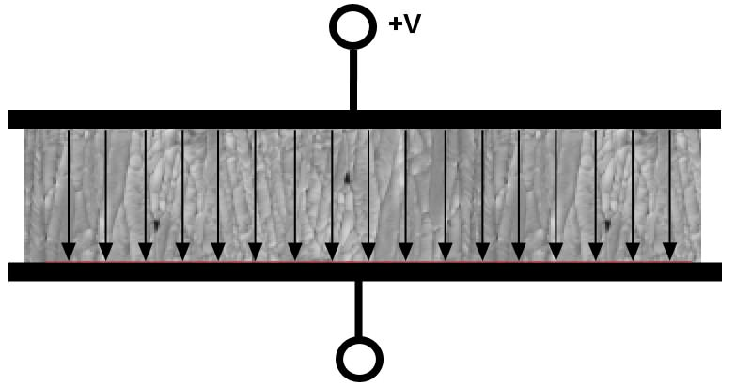
Figure 6 Measurement setup for the parallel case

Both (III.6) and (III.11) were obtained under the assumption of xy isotropy that no longer holds for this case. But let’s prove that isotropy was a sufficient condition, not a necessary one. Assume that D is not lying along z, but that it has a component normal to it. Not only that this component is irrelevant to a measurement in the above setup, because it wouldn’t contribute to the free charge at the conductor plates, it can’t exist either if the sample is assumed homogeneous at a macroscopic level. If not, ask yourself: what direction in xy would it have? Any direction that you might chose is equally likely in the opposite one, so it simply can’t exist. So (III.5) holds for this case.
$\left|\tilde{D}\right|{\vec{u}}_{3}=ε_{0}{\tilde{K}}_{\text{33}}\left|\tilde{E}\right|{\vec{u}}_{3}+{\vec{u}}_{3}ε_{0}{\int_{V}{\sum_{i}{{ΔK}_{i3}{ΔE}_{i}}\text{dv}}}/V$ (III.32)
Sample homogeneity requires that any ΔE_{i}, if i different than 3, you can always find another dv with a same ΔΚ_{i3} but with a ΔE_{i} of opposite sign. This is because nothing relates ΔΚ_{i3} to ΔE_{i}. On the other hand, ΔΚ₃₃ and ΔE₃ are indeed related, since D₃ must be continuous due to the absence of free charge, this is why you can’t say the same for ΔΚ₃₃ and ΔE₃, if one is over the average, the other must be below the average. So, this is the only term that can contribute to the volume integral. We can conclude that, after all, it is safe to use (III.6) for this case too.
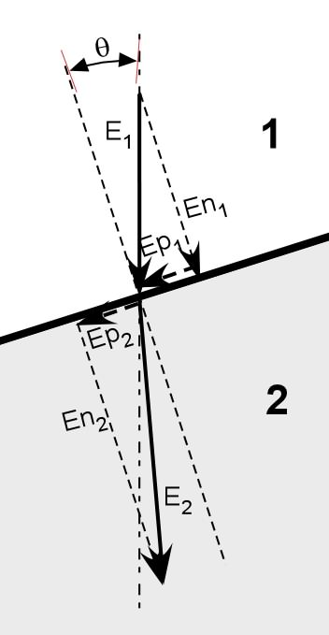
Figure 2 Intercrystallite interface showing components for vector E

Following similar logic as for equations (III.16) to (III.26), but for Figure 5.
Since the parallel component of E must be continuous at the surface to comply with$∇\text{xE}=0$, then:
${\text{Ep}}_{1}={\text{Ep}}_{2}$ (III.33)
Since there is no free charge at the interface D must be continuous.
$\text{Dn}={\text{Kn}}_{1}{\text{En}}_{1}={\text{Dn}}_{2}={\text{Kn}}_{2}{\text{En}}_{2}⇒{\text{En}}_{2}=({{\text{Kn}}_{1}}/{{\text{Kn}}_{2}}){\text{En}}_{1}$ (III.34)
$\begin{aligned}{\text{En}}_{1}=\tilde{E}\text{cos}θ \\ \text{and} \\ {\text{Ep}}_{1}=\tilde{E}\text{sin}θ\end{aligned}$ (III.35)
But:
${\text{Ez}}_{2}={\text{En}}_{2}\text{cos}θ+{\text{Ep}}_{2}\text{sin}θ={\text{En}}_{1}({{\text{Kn}}_{1}}/{{\text{Kn}}_{2}})\text{cos}θ+{\text{Ep}}_{1}\text{sin}θ$ (III.36)
Kn₁ must also correspond to the average case. Combining (III.35) and (III.36) and denoting Kn₁ as$\tilde{K}n$.
${\text{Ez}}_{2}=\tilde{E}+(\tilde{K}n/{{\text{Kn}}_{2}}−1)\tilde{E}{\text{cos}}^{2}θ$ (III.37)
(III.37) can be used to express the relative deviation defined by:
${{ΔE}_{3}}/{\tilde{E}}={{ΔE}_{z}}/{\tilde{E}}=({\text{Ez}}_{2}−\tilde{E})/{\tilde{E}}$ (III.38)
Combining (III.21) and (III.20)
${{ΔE}_{3}}/{\tilde{E}}=(\tilde{K}n/{{\text{Kn}}_{2}}−1){\text{cos}}^{2}θ$ (III.38)
Equation (III.6) can be manipulated into:
$(\left\langle K\right\rangle −\tilde{K})/{\tilde{K}}=\int_{V}{({{ΔK}_{\text{33}}}/{\tilde{K}})(}{{ΔE}_{3}}/{\tilde{E}}){\text{dv}}/V$ (III.39)
Where the right hand side of (III.39) ($(\left\langle K\right\rangle −\tilde{K})/{\tilde{K}}$) is the relative error when considering the effective value as the average.

Again we can take dv to be the fractional volume occupied by crystallites having it’s a lattice axis inclined by an angle between, say, ϕ and ϕ +dϕ, respect to the sample’s symmetry-axis, only here it is not parallel to z, but normal to it. For inclinations in the xz plane, it can be said that ϕ = π /2 - θ, but inclinations along the xy plane don’t contribute at all to θ or to error that we are estimating. We would be over estimating if we calculate the error assuming the whole fractional volume in the vicinity of ϕ=π/2−θ to be contributing. Then for the actual fractional volume it can be said that:
${\text{dv}}/V<\frac{p(π/2−θ)\text{sin}(π/2−θ)dθ}{2}$ (III.40)
Continuing with mentioned logic we come down to:
$(\left\langle K\right\rangle −\tilde{K})/{\tilde{K}}<\int_{{−π}/2}^{π/2}{(K_{\text{33}}(θ)/{\tilde{K}}−1)}(\tilde{K}n/{{\text{Kn}}_{2}}−1){\text{cos}}^{2}θ\frac{\text{cos}θ}{2}p(π/2−θ)dθ$
Taking extreme values as in (III.30) and changing the integration variable back to ϕ:
$\text{abs}(\left\langle K\right\rangle −\tilde{K})/{\tilde{K}}<\text{abs}(({\text{Ka}}/{\text{Kb}}−1)({\text{Kb}}/{\text{Ka}}−1)\int_{0}^{π}{\frac{{\text{sin}}^{3}ϕ}{2}}p(ϕ)dϕ)$ (III.41)
The integration limits order is irrelevant, since we are dealing absolute values only. Nature is beautiful, simple assumptions led to the same expression for K with the parallel case. Evaluating with data from (III.27) we get the same relative error for K
$\text{abs}(\left\langle K\right\rangle −\tilde{K})/{\tilde{K}}<\text{abs}(−0\text{.}\text{73})=7\text{.}3$% (III.42)

III.h Effective Dielectric Constant Calculation, Perpendicular Case

Fuentes et. al. (Ref. 12), using the expansion of p(θ) in spherical harmonics, obtained a longitudinal surface for a textured sample. Their calculation assumes const E and as a result, the value obtained for K₁₁ (or K₂₂) is quite close to the experimental one, but not so for K₃₃. Below we recalculate this value taking into account the findings in this study.

K₃₃ is the tensor component relevant for the perpendicular case. As proved in III.3, the best approximation to a volume average is obtained with D as independent variable. Since the volume average of the I tensor is equal to the volume average of its components:
${\tilde{I}}_{\text{ij}}=1/V\int_{V}{I_{\text{ij}}\text{dv}}$ (III.43)
Let Ip be the tensor in the system of reference of eigenvectors, then:
${\text{Ip}}_{\text{ij}}=δ_{\text{ij}}{\text{Ip}}_{\text{ij}}$ (III.44)
Where the z or axis number 3, will lie along the (001) direction, and so:
$\begin{aligned}{\text{Ip}}_{\text{11}}=\text{Ic} \\ {\text{Ip}}_{\text{22}}=\text{Ib} \\ {\text{Ip}}_{\text{33}}=\text{Ia}\end{aligned}$ (III.45)
Any particular volume element dv will have its principal axis system rotated from the sample reference system. Let A be the rotation tensor that transforms a vector from the element to the sample’s system. Then:
$I=A^{−1}\text{IpA}$ (III.46)
Or
$I_{\text{ij}}=\sum_{\text{kl}}{a^{{−1}_{\text{ik}}}{\text{Ip}}_{\text{kl}}a_{\text{lj}}}$ (III.47)
Since we know that <E> and $\tilde{D}$ only have components in z, then only the average of I₃₃ is of interest to this perpendicular measurement, combining (III.47) with (III.44):
$I_{\text{33}}=a^{{−1}_{\text{31}}}{\text{Ip}}_{\text{11}}a_{\text{13}}+a^{{−1}_{\text{32}}}{\text{Ip}}_{\text{22}}a_{\text{23}}+a^{{−1}_{\text{33}}}{\text{Ip}}_{\text{33}}a_{\text{33}}$ (III.48)
Now according to Math World (Ref. 14), a_{ij} can be expressed in terms of the Euler angles as:

a11 (III.49)
(III.50)
(III.51)
(III.52)
(III.53)
(III.54)
(III.55)
(III.56)
(III.57)
Where the angles are:
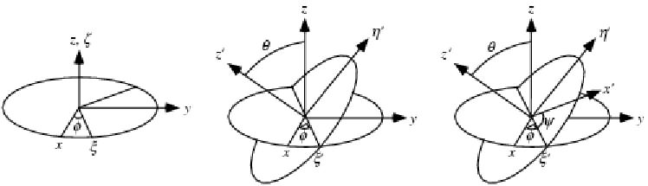
Figure 7 Euler angles

For $A(φ,θ,ψ)$ it is true that:
$A^{−1}(φ,θ,ψ)=A(−ψ,−θ,−φ)$ (III.58)
Because this is how you would undo the rotation.
Combining (III.48), (III.51), (III.54), (III.57) and (III.58):
$I_{\text{33}}={\text{Ip}}_{\text{11}}{\text{sin}}^{2}θ{\text{cos}}^{2}φ+{\text{Ip}}_{\text{22}}{\text{sin}}^{2}θ{\text{sin}}^{2}ψ+{\text{Ip}}_{\text{33}}{\text{cos}}^{2}θ$ (III.59)
As we have been doing before (justifying equation (III.24)), let’s change dv/V into the fractional volume of the elements with orientation g in an infinitesimal orientation interval dg or f(g)dg, the Orientation Distribution Function (ODF). In terms of the Euler angles, elements that have their principal axes rotated with angles between $θ$and $θ+dθ$, φ and$φ+dφ$ and $ψ$ and $ψ+dψ$. This is an element of volume in the Euler space affected by a probability distribution , that for this particular case of a fiber texture is only a function of $θ$, which none other than the (0,0,1) Direct Pole Figure p(θ):
${\text{dv}}/V=(1/8π^{2})p(θ)\text{sin}θdθdφdψ)$ (III.60)
Where p(θ) is normalized so that:
$\int{\frac{p(θ)\text{sin}θdθ}{2}}=1$ (III.61)
Combining (III.59), (III.60) and (III.43):
${\tilde{I}}_{\text{33}}=\int{\int{\int{\begin{aligned}\left({\text{Ip}}_{\text{11}}{\text{sin}}^{2}θ{\text{cos}}^{2}φ | \right)\left(+{\text{Ip}}_{\text{22}}{\text{sin}}^{2}θ{\text{sin}}^{2}ψ | \right) \\ \end{aligned}}}}$ (III.62)
Since the integrand is continuous, we can do the integration in any order. Doing it first over $φ$and $ψ$ renders:
${\tilde{I}}_{\text{33}}=\int{\left(\frac{({\text{Ip}}_{\text{11}}+{\text{Ip}}_{\text{22}})}{2}{\text{sin}}^{2}θ+{\text{Ip}}_{\text{33}}{\text{cos}}^{2}θ\right)\frac{p(θ)\text{sin}θdθ}{2}}$ (III.63)
If Ip₁₁= Ip₂₂=Ip₃₃=I, equation (III.63) reduces nicely to${\tilde{I}}_{\text{33}}=I$. If there where no texture, this is a flat distribution or p(θ) =1, then (III.62) reduces to${\tilde{I}}_{\text{33}}=\frac{{\text{Ip}}_{\text{11}}+{\text{Ip}}_{\text{22}}+{\text{Ip}}_{\text{33}}}{3}$, which perfect physical sense, since no particular lattice orientation can prevail. Also, a perfect texture or, in other words, an infinitely sharp distribution that stays normalized, that is the definition of the Dirac delta.
$\int{\frac{p(θ)\text{sin}θdθ}{2}}=\int{δ(θ)dθ=}1$ (III.64)
Combining (III.63) and (III.64), we can see one more time that (III.63) is physically sound, since now it reduces to ${\tilde{I}}_{\text{33}}={\text{Ip}}_{\text{33}}$.

If we assumed the same Gaussian distribution with the 23º variance (001) PF we used for estimating the error and the values in (III.28) from Ref. 6, we get${\tilde{I}}_{\text{33}}=0\text{.}\text{00775}$ from (III.63) or $\left\langle K\right\rangle =\text{129}$, which makes perfect sense, a little over the single crystal’s Ka in (III.27) for a fairly structured sample. Yet, using the PowderCell program we could find the March-Dollase distribution for the IPF that best fitted the reported XRD. Figure 8a below shows the XRD pattern for the Nd doped sample of Ref. 4, while Figure 8b shows its best fitting distribution.
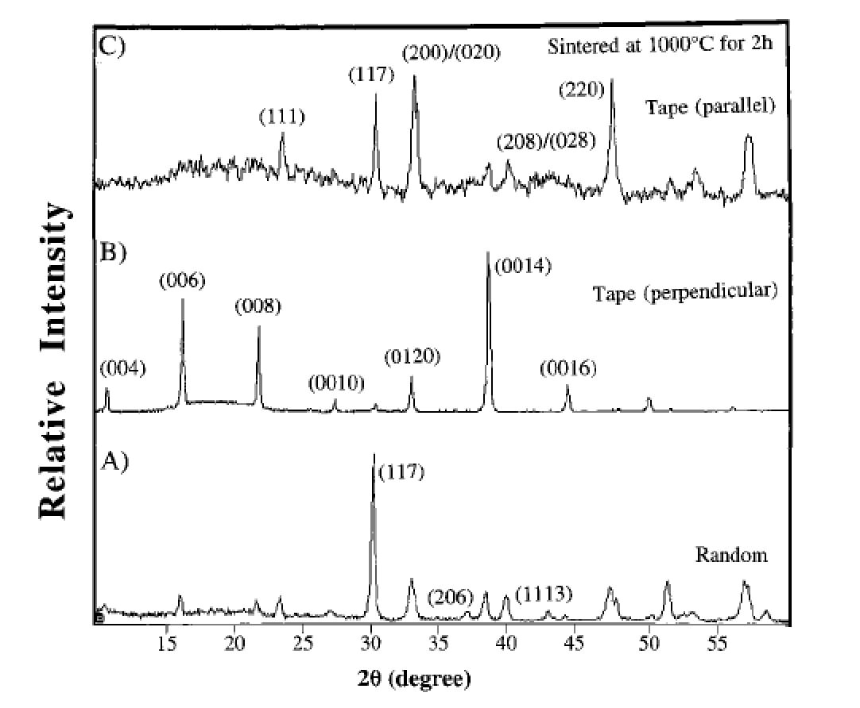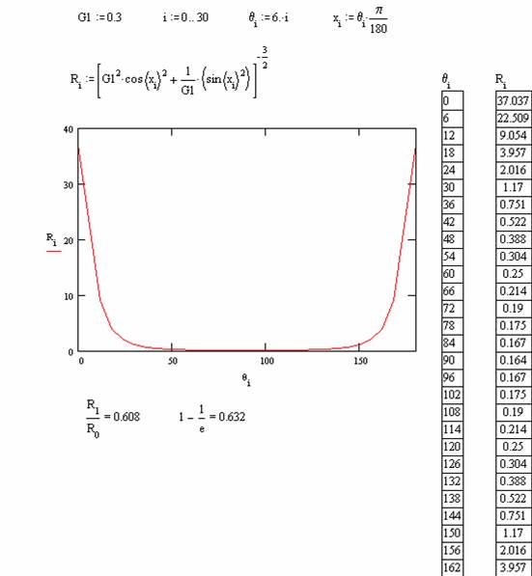
Figure 8a XRD and 8b March-Dellose distribution for the Nd Doped Bismuth Titanate Sample

A direct pole figure with a Gaussian distribution with a 7.8º variance would correspond very neatly to this IPF. Using this value in equation (III.63), renders what would be expected for a more textured sample:
$\left\langle K\right\rangle =\text{122}$ (III.65)

III.i Effective Dielectric Constant Calculation, Parallel Case

Calculations in Ref. 2 for the parallel case were correct, since a constant E was assumed, but since here a different ceramic is being considered, the dielectric constant must be recalculated with the corresponding data. From Ref. 2, the expression for the dielectric longitudinal surface expansion in symmetrized spherical harmonics for of the single crystal is:
$e(θ,φ)=e_{0}^{1}k_{0}^{1}(θ)+e_{2}^{1}k_{2}^{1}(θ)+e_{2}^{2}k_{2}^{2}(θ,φ)$ (III.66)

Where the e’s are the expansion coefficients for the permittivity longitudinal surface:
$\begin{aligned}e_{0}^{1}=\frac{2}{3}\sqrt{π}(e_{\text{11}}+e_{\text{22}}+e_{\text{33}}) \\ e_{2}^{1}=\frac{2}{3}\sqrt{π/5}(2e_{\text{33}}−e_{\text{11}}−e_{\text{22}}) \\ e_{2}^{2}=\frac{2}{3}\sqrt{π/5}(e_{\text{11}}−e_{\text{22}})\end{aligned}$ (III.67)
And the k’s are the actual symmetrized spherical harmonics:
$\begin{aligned}k_{0}^{1}=\frac{1}{2\sqrt{π}} \\ k_{2}^{1}(θ)=\frac{1}{4}\sqrt{5/π}(3{\text{cos}}^{2}θ−1) \\ k_{2}^{2}(θ,φ)=\frac{1}{4}\sqrt{{\text{15}}/π}{\text{sin}}^{2}θ{\text{cos}}^{2}2φ\end{aligned}$ (III.69)
Now similarly, we expand the March-Dellose p(θ) distribution in symmetrized spherical harmonics, the coefficients being:
$\begin{aligned}p_{0}^{1}=\frac{1}{2\sqrt{π}}\int{p(θ)dθ} \\ p_{2}^{1}=\frac{1}{4}\sqrt{5/π}\int{p(θ)}(3{\text{cos}}^{2}θ−1)dθ \\ p_{2}^{2}(θ,φ)=0\end{aligned}$ (III.69)
The expression for the dielectric longitudinal surface being:
$e_{\text{sample}}(θ)=p_{0}^{1}e_{0}^{1}k_{0}^{1}+p_{2}^{1}e_{2}^{1}k_{2}^{1}(θ)$ (III.70)
The dielectric constant for the parallel case being:
$Ky=e_{\text{sample}}({\text{90}}^{o})/{ε_{0}}$ (III.71)
The Math Cad software package rendered for (III.71):
$Ky=\text{160}$ (III.72)

III.j Comparison to experimental results

The dielectric constant parallel to the 011 direction calculated using the approach in Ref. 12, rendered a value of 144.7 which is way too high when compared with experimental data in Ref.2. Calculation using D as independent variable rendered a value of 122 which is much better match as is shown in Figure 9. When comparing the present calculations to the experimental data, a couple of differences must not be overlooked: the constants assumed for the crystallite may not be exactly the same as the original samples measured in Ref. 7, the process used for the samples in Ref. 2, is tape casting that does not render cylindrical samples as suggested by Figures 1 and 5.
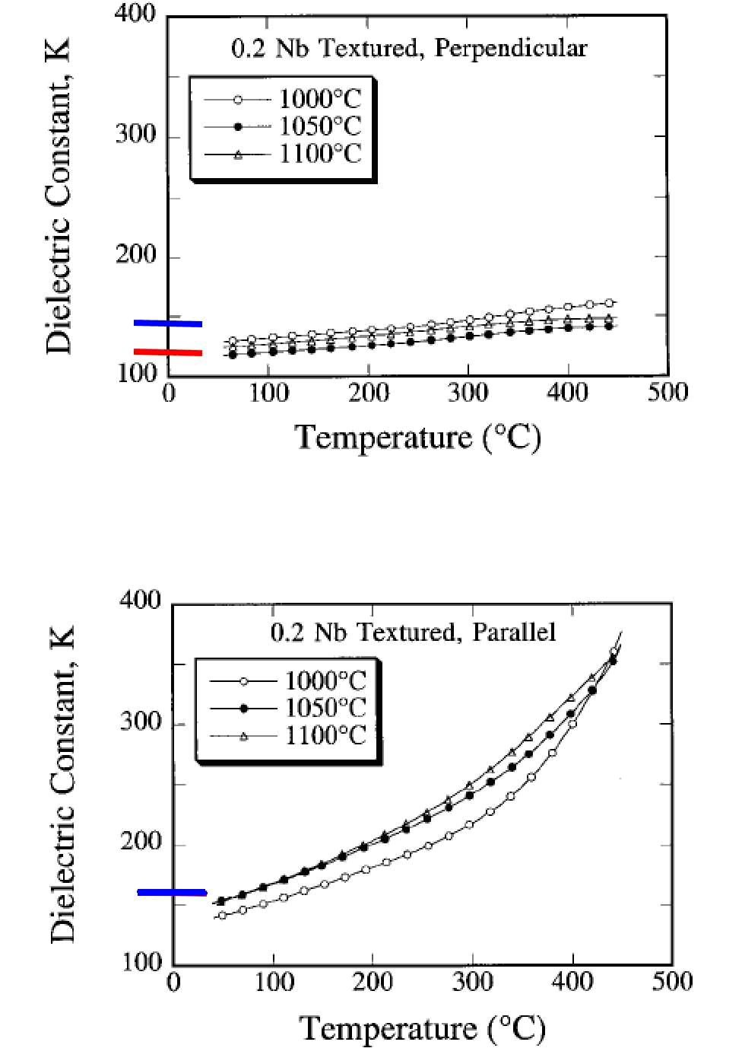
Figure 9 Comparison with experimental data: in blue, calculation from Ref. 12; in red calculation from equation III.63

Longitudinal surface for the Bismuth Titanate ceramic has been corrected to be as shown in Figure 10. The single crystal longitudinal surface is also shown for easy comparison.

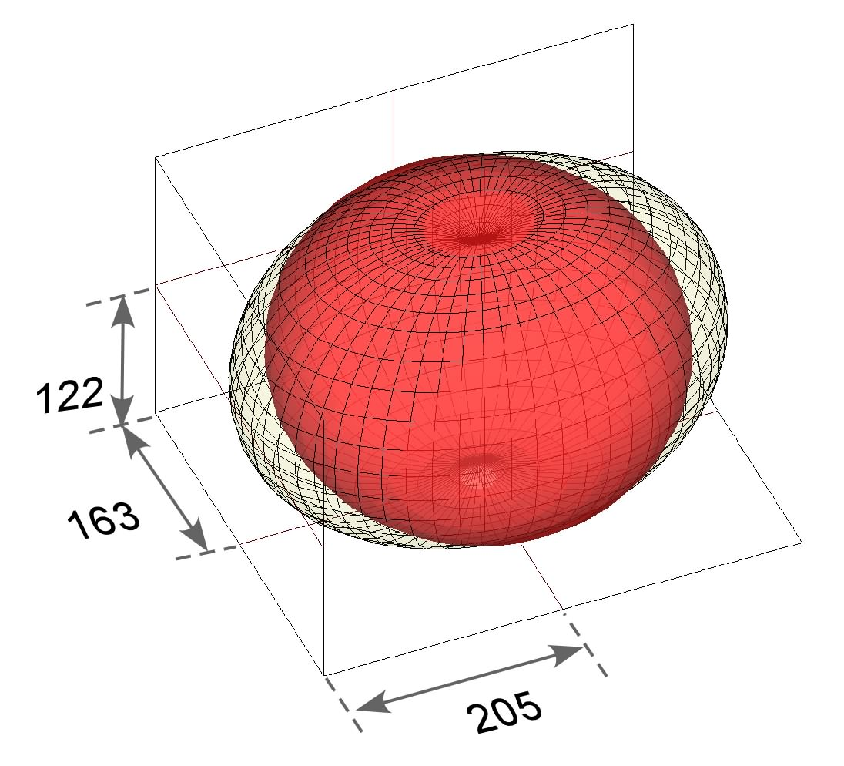
Figure 10 Dielectric longitudinal surfaces for Bismuth Titanate; grided surface represents the single crystal data; red the textured ceramic.

IV Conclusions

- It was established that the volume averages of E and D associated to the measured V and Q respectively for the common experimental setups.
- It was proved that $(1/{\tilde{I}})≤\left\langle K\right\rangle ≤\tilde{K}$ assuming homogeneous samples under common measurement setups.
- For textured ceramics the relative error in taking the average as the effective impermittivity in the perpendicular case is: $\text{abs}(\left\langle I\right\rangle −\tilde{I})/{\tilde{I}}<\text{abs}(({\text{Ia}}/{\text{Ib}}−1)({\text{Ib}}/{\text{Ia}}−1)\int_{0}^{π}{\frac{{\text{sin}}^{3}θ}{2}}p(θ)dθ)$
  - Error is smaller for highly textured samples
  - Error increases with anisotropy
- For textured ceramics the relative error in taking the average as the effective permittivity in the parallel case is: $\text{abs}(\left\langle K\right\rangle −\tilde{K})/{\tilde{K}}<\text{abs}(({\text{Ka}}/{\text{Kb}}−1)({\text{Kb}}/{\text{Ka}}−1)\int_{0}^{π}{\frac{{\text{sin}}^{3}ϕ}{2}}p(ϕ)dϕ)$
- Assuming a Gaussian ODF with a 23º variance, the errors were found to be less than 7.3% for asymmetries reported for the Bismuth Titanate samples of Ref. 2.
- The dielectric constant parallel to the 011 direction calculated using the approach in Ref. 12, rendered a value of 144.7 which is way too high when compared with experimental data in Ref.2. Calculation using D as independent variable rendered a value of 122, which is much better match.
- Longitudinal surface for the Bismuth Titanate ceramic has also been corrected and sketched together with the single crystal longitudinal surface.

CENTRO DE INVESTIGACIÓN EN MATERIALES AVANZADOS, S. C.
POSGRADO

PERMITIVIDAD MEDIA Y EFECTIVA DE FERROELÉCTRICOS TEXTURADOS

Tesis que como Requisito para Obtener el
Grado de Maestro en
Ciencia de Materiales presenta:

Lic. Armando Rodríguez

Director de Tesis:
Dr. Luis E. Fuentes Cobas

Chihuahua, Chih. Diciembre de 2006
References:

J. F. Nye, Physical Properties of Crystals: Their representation by tensors and matrices. Clarendon Press, Oxford (1957).
L. Fuentes, Ma. E. Fuentes, La Relación Estructura-Simetría –Propiedades en Cristales y Policristales, Soc. Mex. de Cristalografía (2006).
IEEE Standards on Piezoelectricity ANSI/IEEE Std. 176 (1987).
R. Feynman, R. B. Leighton, L. M. Sands, Lectures on Physics, Vol. 2, Addison-Wesley (1989).
J. D. Jackson, Classical Electrodynamics, Wiley, N. York (1975).
H.J. Bunge, Texture Analysis in Materials Science. Butterworths (1982).
Bunge, H. J. “Texture – the key to physics of polycrystalline materials”. Materials Science Forum 273-275, 3 (1998).
Zuo, L., Humbert, M., Esling, C. Elastic properties of polycrystals in the Voigt-Reuss-Hill approximation. J. Appl. Cryst. 25, 751 (1992).
Humbert, M., Wagner, F., Philippe, M. J., Esling, C., Relation between texture and anisotropic properties: some applications to low symmetry materials. Text. and Microstruct., 14-18, 443-461 (1991).
Fuentes, L.; Raymond, O. “Texture, piezoelectricity and ferroelectricity”. Textures and Microstructures, 23, 221 (1995).
Fuentes, L.; Jiménez, B.; Ríos-Jara, D. “El problema de la textura en ferroeléctricos de Aurivillius”. Bol. Soc. Esp. Cerám. y Vidrio 38, 394 (1999).
L. Fuentes, A. Rodríguez, G. Aquino de los Ríos, A. Muñoz-Romero, Modeling the Influence of Texture on the Properties of Electroceramics, Integrated Ferroelectrics, 71, 289–301 (2005).
H. Camacho-Montes, R. Rodriguez-Ramos, J. Bravo-Castillero, R. Guinovart-Diaz, F. J. Sabina, Effective coefficients for two phase magneto-electroelastic fibrous composite with square symmetry cell in-plane mechanical displacement and out-of-plane electric and magnetic field case. Integrated Ferroelectrics, 83, 49-65 (2006).
Seong-Hyeon Hong, S. Trolier-McKinstry, G. L. Messing, Dielectric and Electromechanical Properties of Textured Niobium-Doped Bismuth Titanate Ceramics, J. Am. Ceram. Soc., 83 [1] 113–118 (2000).
http://mathworld.wolfram.com/EulerAngles.html
R. Feynman, “You are Surely Joking Mr. Feynman”.
A. Fouskova, L. E. Cross, “Dielectric Properties of Bismuth Titanate,” J. Appl.Phys., 41, 2834–38 (1970).
In-Sook Yi and Masaru Miyayama, Materials Res.Bull. 32, 1349 (1997).
http://users.omskreg.ru/~kolosov/bam/a_v/v_1/powder/e_cell.htm
L. Fuentes, Introducción al Método de Rietveld, Soc. Mex. de Cristalografía, Cd. México (2006).

